The Finnish phoenix: How Nokia is slowly reinventing itself

**Europe’s former electronics giant is quietly positioning itself to be the leader of the networking arms race**

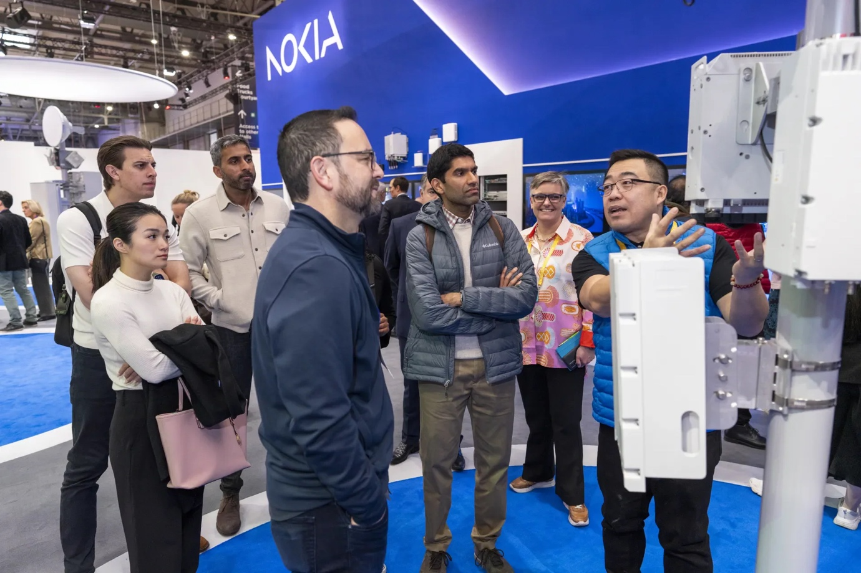

*Demonstration in Nokia’s booth at Mobile World Congress 2024. Photo: Nokia Newsroom*

There is perhaps no technological fall-from-grace more catastrophic than Nokia. A brand once synonymous with the very concept of mobile telephony has now nearly vanished in the consumer space. But for the past decade, the company has been quietly renovating itself.

At the start of 2007, Nokia held half of the smartphone market. But Apple’s introduction of the iPhone in January reshaped the industry, and by 2010 Nokia’s lead had entered freefall.

Upon the entry of new chief executive Stephen Elop that year, the New York Times would describe Nokia as suffering from a “culture of complacency”. Elop infamously declared it as standing on a “burning platform”, thus striking a partnership with his former employer Microsoft to exclusively use their Windows Phone software and focus on unique hardware.

The gambit failed, with Nokia selling its “Devices and Services” division to Microsoft in 2013 for 5.44 billion Euros. By then Nokia’s share of the smartphone market stood at just three percent. Microsoft would write off the sale two years later, laying off over 20,000 employees and eventually leaving the smartphone business. Nokia Corporation, meanwhile, would continue operating as a network infrastructure company.

Since then Nokia’s efforts in the consumer space have been few and far between. A brand licensing deal with start-up HMD Global, comprised primarily of former Nokia employees, led to the launch of a series of Nokia-branded smartphones powered by Google’s Android platform in 2017. These failed to make a strong dent in the mobile market. HMD recently signalled it intends to pivot to own-branded devices instead.

Other efforts include OZO, a virtual reality camera; and an acquisition of health brand Withings, which was promptly sold back to its co-founder two years later. Despite these misfires, it suggests an entirely new culture has taken root at Nokia – risky, far from the complacency of the 2000s.

At the heart of the company’s rebirth, however, is its aforementioned networking business. Following a 2015 merger with French giant Alcatel-Lucent, Nokia Corp. now sits as the world’s second-largest telecommunications equipment manufacturer, per a Dell’Oro Group report.

The current leader, China’s Huawei, has faced increasing regulatory scrutiny and collapsing market share in the West. After repeated sanctions imposed by the U.S. starting in 2019, several nations have effectively banned its equipment from their 5G infrastructure. In a 2022 company-wide speech, CEO Ren Zhengfei stated “[Huawei] will give up markets in the Five Eyes markets and India.” Politico described the move as “putting its global ambitions on ice”.

While Huawei continues to be a technological rival, they have effectively been forced to retrench into their home market. This opens up a tremendous opportunity for Nokia, whose Finnish roots keep it untangled from U.S.-China tensions and sanctions. With many nations now unable or unwilling to use Huawei equipment, yet still hungry to build their infrastructure, Nokia stands to gain a lot.

Nokia now has an opportunity to reclaim a throne atop the telephony market, albeit in an entirely new way. Can this Finnish phoenix rise again?

*Word count: 500 (excluding byline/caption)*

References:

*Image source: Nokia at MWC 2024 (Nokia Newsroom, 2024)*

<https://www.nokia.com/about-us/newsroom/media-resources/media-library/nokia-at-mwc-2024/>

*Global market share held by Nokia smartphones from 1st quarter 2007 to 2nd quarter 2013* (IDC, 2013, via Statista) <https://www.statista.com/statistics/263438/market-share-held-by-nokia-smartphones-since-2007/>

*Nokia’s New Chief Faces Culture of Complacency* (The New York Times, 2010) <https://www.nytimes.com/2010/09/27/technology/27nokia.html>

*Microsoft to acquire Nokia’s devices & services business, license Nokia’s patents and mapping services* (Microsoft, 2013) <https://news.microsoft.com/2013/09/03/microsoft-to-acquire-nokias-devices-services-business-license-nokias-patents-and-mapping-services/>

*Nokia phone maker HMD is launching its own smartphone brand* (The Verge, 2023) <https://www.theverge.com/2023/9/12/23869656/nokia-hmd-smartphone-brand-announcement-foxconn>

*NOKIA AND ALCATEL-LUCENT TO COMBINE TO CREATE AN INNOVATION LEADER IN NEXT GENERATION TECHNOLOGY AND SERVICES FOR AN IP CONNECTED WORLD* (Nokia PR, 2015) <https://www.nokia.com/about-us/news/releases/2015/04/15/nokia-and-alcatel-lucent-to-combine-to-create-an-innovation-leader-in-next-generation-technology-and-services-for-an-ip-connected-world/>

*How Washington chased Huawei out of Europe* (Politico, 2022) <https://www.politico.eu/article/us-china-huawei-europe-market/>

*Huawei still reigns over growing telecom equipment sector* (TelecomTV, 2013, data from Dell’Oro Group) <https://www.telecomtv.com/content/access-evolution/huawei-still-reigns-over-growing-telecom-equipment-sector-48457/>