

Is History Repeating? The Return of Vinyl: A Cultural Rebirth.

Vinyl records amongst 16 new items added to UK inflation basket reflective of changing consumer purchase habits.

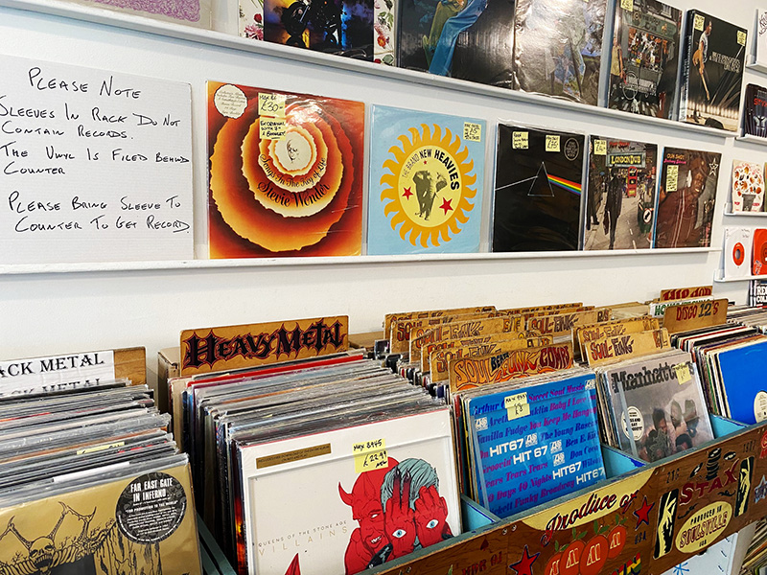

March 22, 2024

After a hiatus spanning more than three decades, vinyl records have returned to the list of products used to measure UK inflation. Added to the basket of goods and services used for monitoring price growth, their resurgence marks a notable development in consumer trends and cultural preferences.

Vinyl records dropped off the list in 1992 as CDs gained popularity due to their lower costs, and increased availability. The introduction of digital music streaming platforms such as Spotify further impacted vinyl sales, as the convenience and affordability of digital formats became increasingly prevalent.

Nevertheless, a significant number of consumers within the music industry continue to yearn for a nostalgic, retro listening experience, relishing in the tangible presence of a physical copy. Vinyl records are now the music industry’s most popular and highest-grossing physical format (The New York Times, 2021) and the return of HMV to its original flagship in London Oxford St underscores the demand for music on physical formats. In the UK, this appeal is vividly reflected in the numbers, with vinyl LP sales surging by 11.7% in 2023, amounting to 5.9 million units (The Creative Industries, 2024). This recovery marks the highest annual level since 1990, signalling a strong revival in traditional music consumption in an increasingly digital age.

With the basket of goods and services reflecting consumer spending patterns, the return of vinyl to the UK inflation basket indicates that vinyl is making a comeback. Matt Corder, ONS deputy director stated, ‘the return of vinyl records shows how cultural revivals can affect our spending’ (The Herald, 2024). The rise of the vinyl has been accelerated with popular music artists new releases. In 2023, seven out of the ten highest-selling vinyl LPs were newly released albums (Official Charts, 2023) indicating a significant contribution from modern music to the rebirth of vinyl records.

Consumers will have to choose whether they strive for a convenient listening experience from digital streams or an immersive listening experience that vinyl records provide. But going into the future, a hybrid mix of the two formats is expected.

However, for vinyl manufacturers the ability to satisfy this increasing demand is becoming a challenge. Despite the automation of many manufacturing processes, the pressing of vinyl records remains a labour-intensive process with many manual steps (Grammy, 2022). Even with growth over the decades, the way records are being made hasn’t changed, and the reliance on old, traditional pressing machines give rise to concerns that this viral resurgence for vinyl’s has exceeded the industrial capacity to sustain it.

The lingering question persists: will this revival of vinyl merely be a passing trend, or will it persist and thrive as a beloved physical format for music consumption in the future? Crucial to determining this trajectory is the ability of manufacturers to meet the escalating demand, a factor pivotal for the sustained growth of the vinyl industry. Should manufacturing delays continue, or consumer preferences change, the existence of vinyl's decline may resurface once more, threatening its return to the music landscape.

Word count: 500

<https://www.nytimes.com/2021/10/21/arts/music/vinyl-records-delays.html>

<https://www.heraldscotland.com/news/24172817.vinyl-revival-records-return-ons-basket-uk-goods/>

<https://www.thecreativeindustries.co.uk/site-content/uk-music-vinyl-sales-highest-in-decades#:~:text=According%20to%20BPI%20analysis%20based,in%20vinyl%20sales%20in%202022>.

<https://www.grammy.com/news/the-vinyl-shortage-explainer-how-long-waits-expensive-materials-high-demand-are-affecting-the-industry>